Report HW 8 ECE-111
Name: Jasper Huang
PID: A17796149

Handshake Synchronizer

SystemVerilog Design Code (Student added parts)

handshake_synchronizer.sv
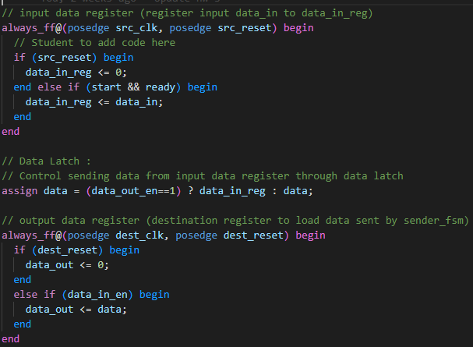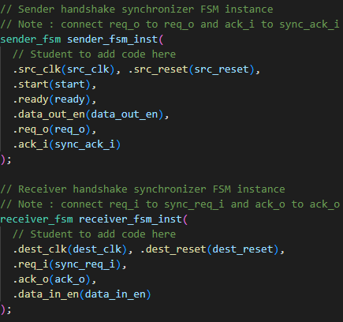
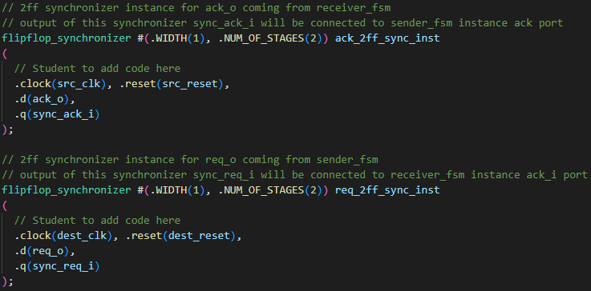

sender_fsm.sv
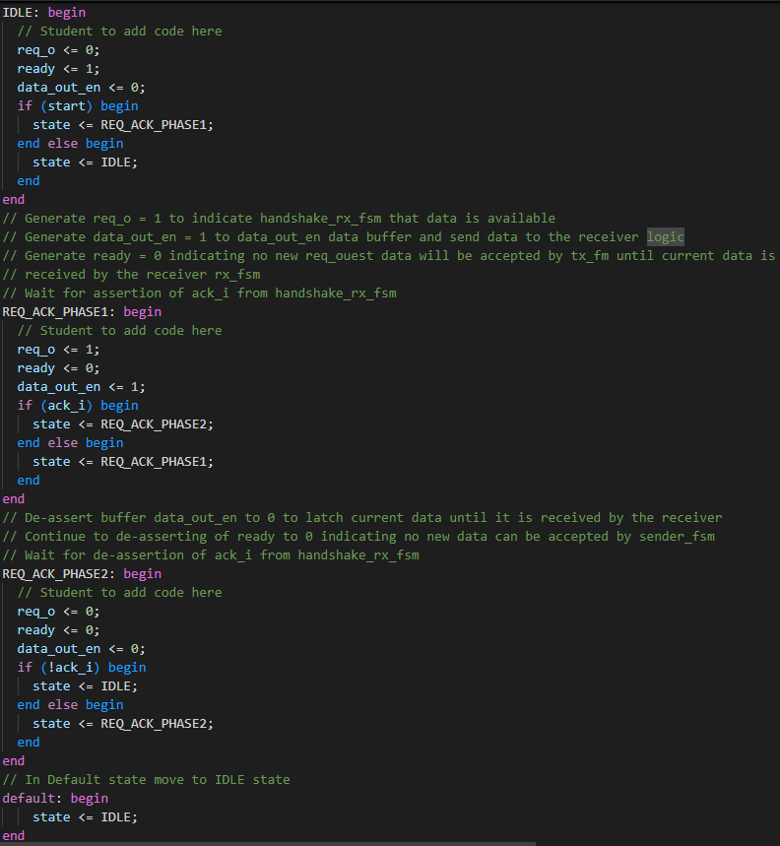

receiver_fsm.sv
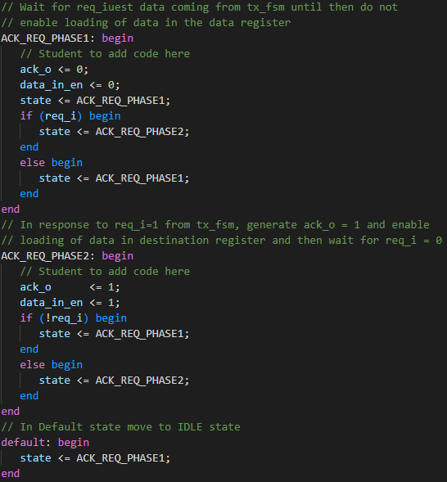

flipflop_synchronizer.sv
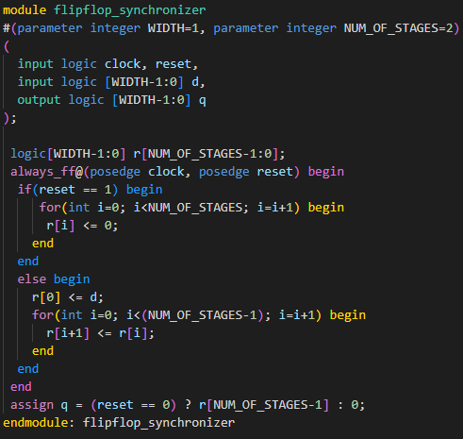

Synthesis resource usage snapshot
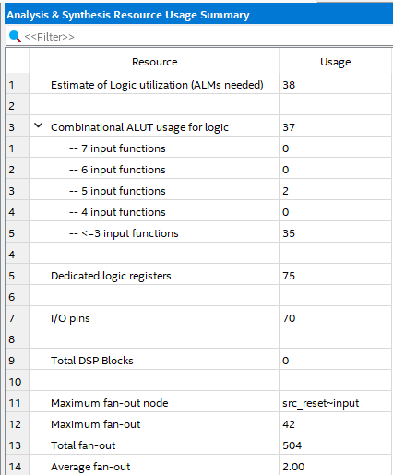
Simulation snapshot
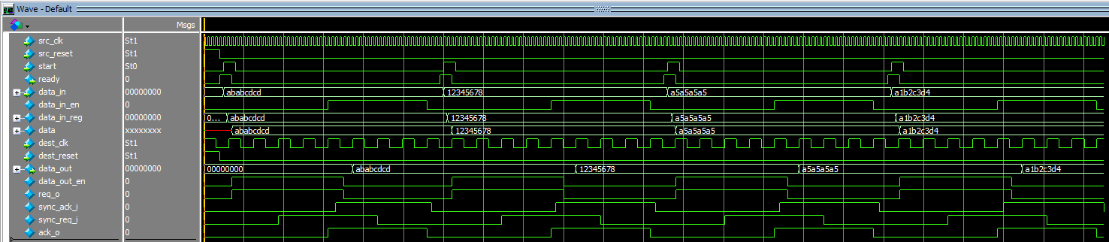
The simulation result shows the sending and receiving of four different data, where you can see for each data_in, the cycle and their corresponding flag is output correctly with the final data_out matching exactly as the data_in.

